Table of Contents
TOPIC 1: STRUTS, SPRING & HIBERNATE INTEGRATION 2
1. Web.xml: 3
2. struts-config.xml: 3
3. ApplicationContext.xml: 3
4. student.jsp 4
5. Servlet Class: 5
6. DAO Class: 6
7. DOMAIN Class: 7
TOPIC 2: Log4J 8
TOPIC 3: JASPER REPORT 8
TOPIC 4: SPRING BOOT & MYBATIS INTEGRATION WITH HSQL DATABASE 9
1. Create a SpringBoot Maven project and add following MyBatis Starter Dependency: 9
2. Create Domain class: 9
3. Create schema.sql: 9
4. Create data.sql: 10
5. Create MyBatis SQL mapper interface (UserMapper.java): 10
6. Create UserMapper.xml: (Using XML configuration) 10
7. Create UserMapper.java: (Using annotation configuration) 11
8. Application.properties: 11
9. Application.java: 11
10. JUnit Test Class: 11
TOPIC 5: JAVA 8 SHORT NOTES 12
1. Default Method in Interface: 12
2. Static method in Interface: 13
3. Repeating Annotations: 13
4. Lambda Expressions: 14
4.1 Syntax: 14
4.2 Functional Interface: 15
4.3 Method References: 15
4.4 Traversing Collections using Lambda: 15
5. Streams: 16
5.1 Types of Operations: 16
5.2 Parallel Streams: 17
6. Optional Class: 18
7. Need for Date / Time API: 18
7.1 Local Date : 18
7.2 Local Time : 19
8. Java Basics: 20
8.1 Access Control : 20
8.2 Non Access Control : 20
8.3 Collections : 20
TOPIC 6: Angular JS 6 NOTES 21
1. What and Why?: 21
2. Angular’s History: 21
3. Angular’s Architecture: 22
4. Important files in Angular app: 22
5. Componants: 23
6. Interpolation: 23
6.1 Things can be done in Interpolation: 23
6.2 Things can not be done in Interpolation: 24
7. Property Binding: 24
7.1 Attributes vs Properties: 24
8. Class Binding: 25
9. Style Binding: 25
10. Event Binding: 26
11. Reference variable: 26
12. Two way Binding: 26
TOPIC 7: Docker 27
1. Docker Commands: 27
7.1 Basic Docker Commands: 27
2. Docker Images: 28
3. Docker Compose: 29
4. Docker Registery: 31
5. Docker Engine: 33
6. Docker Storage: 33
7. Docker Networking: 33
TOPIC 8: Spring Security 34
1. Dependecy: 34
2. How it works: 34
3. Steps Involved JDBC Authentication: 35
3.1 SecurityConfig: 35
4. Steps Involved JPA Authentication: 36
4.1 SecurityConfig: 36
4.2 User Details Service: 36
4.3 User Details Model: 37
4.4 User & Role Model: 37
5. Steps to enable HTTPS in spring boot: 38
5.1 Create certificate using java: 38
5.2 Update application.properties file: 39
5.3 Add bean into our application: 39
TOPIC 9: Gitlabee 40
1. .gitlab-ci.yml: 40
1.1 Manage Secrets: 41
1.2 Yaml Basics: 41

TOPIC 1: STRUTS, SPRING & HIBERNATE INTEGRATION
VERSIONS USED:
- STRUTS (1.5)
- SPRING (3.0)
- HIBERNATE (3.0)

1. Web.xml:
<servlet>
<servlet-name>action</servlet-name>
<servlet-class>org.apache.struts.ActionServlet</servlet-class>
<init-param>
<param-name>config</param-name>
<param-value>/WEB-INF/struts-config.xml</param-value>
</init-param>
</servlet>
<servlet-mapping>
<servlet-name>action</servlet-name>
<url-pattern>*.do</url-pattern>
</servlet-mapping>
<welcome-file-list>
<welcome-file>index.jsp</welcome-file>
</welcome-file-list>

2. struts-config.xml:
<form-beans>
<form-bean
name = “studentForm”
type=”org.apache.struts.validator.DynaValidatorForm” >
<form-property name= “studentId” type =”java.lang.Interger” initial=”java.lang.Interger” />
(Add many form properties for current form.)
</form-bean>
</form-beans>
<action-mappings>
<action path - “/studentAction” type=”org.springfw.web.struts.delegatingActionProxy”
parameter=”dispatch”
input=”/student.jsp”
scope=”request”
name=”studentForm”
validate=”false” />
</action-mapping>
<message-resources parameter=”com.ApplicationResources” key=”lable”/>

<plug-in className=”org.springfw.web.struts.ContextLoaderPlugIn” >
<set-property property=”contextConfigLocation”
value=”/WEB-INF/classes/applicationContext.xml />
</plug-in>

3. ApplicationContext.xml:
//View Beans
<bean name=”/studentAction” class=”com.action.StudentAction” >
<property name=”stutdentBD” ref=”studentBD”/>
</bean>

//Business Delegation Beans
<bean id=”studentBD” class=”com.BDImpl.StudentBDImpl”>
<property name=”studentDAO” ref=”studentDAO” />
</bean>

//Data Access Object
<bean id=”studentDAO” class=”com.DAOImpl.StudentDAOImpl”>
<property name=”sessionFactory” ref=”sessionFactory” />
</bean>

// Database Connection
<bean id=”dataSource”
class=”org.springfw.jdbc.datasource.DriverManagerDataSource” >
<property name=”driverClassName” value=”com.mysql.jdbc.Driver” />
<property name=”url” value=”jdbc:mysql://localhost:3306/{{dbName}} />
<property name=”username” value=”root” />
<property name=”password” value=”xxxx” />
</bean>

<bean id=”sessionFactory” class=”org.springfw.orm.hibernate3.annotation.AnnotationSessionFactoryBean” >
<property name=”dataSource” ref=”dataSource” />
<property name=”annotatedClasses”>
<list>
<value>com.domain.Student</value>
<value>com.domain.Course</value>
</list>
</property>
<property name=”hibernateProperties”>
<props>
<prop key=”hibernate.dialect”>org.hibernate.dialect.MySQLDialect</prop>
<prop key=”hibernate.show-sql”>true</prop>
<prop key=”hibernate.format-sql”>true</prop>
<prop key=”hibernate.use-sql-comments”>true</prop>
<prop key=”hibernate.hbm2ddl.auto”>update</prop>
</props>
</property>
</bean>

4. student.jsp
//Ajax using JavaScript
var ajaxObj;
if(window.XMLHttpRequest){
ajaxObj=new XMLHttpRequest();
}elseIf(window.ActiveXObject){
ajaxObj=new ActiveXObject(“MICROSOFT.XMLHTTP”);
}

function addStudent(){
var studentName=document.getElementById(“name”).value;
var url = “studentAction.do?dispatch=addStudent &studentName=”+studentName+” &studentAge=”+studentAge;
ajaxObj.open(“POST”,url,true);
ajaxObj.onreadyStateChange=function(){
if(ajaxObj.readyState==4 && ajaxObj.status==200){
d.getElementById(“div 1”).innerHtml = ajaxObj.responseText;

//To Add elements dynamically in combo box using ajax
var select = d.getElById(“item”);
var EnumList=eval(‘(‘+ajaxObj.responseText+’)’);
var loadToCombo=EnumList[‘LOADLIST’];
for (var i =0; i<loadToCombo.length;i++){
select.options[select.options.length]=new option(loadToCombo[i],loadToCombo[i+1];
i++;
}
}
}
ajaxObj.send();
}

5. Servlet Class:
public Class StudentAction extends DispathAction{
private StudentDAO studentDAO;
//Create getters & setters for studentDAO
public ActionForward addStudent(ActionMapping map, ActionForm form, HttpServletRequest req, HttpServletResponse res) throws Exception{
String name = req.getParameter(“studentName”);
int age = Interger.parseInt(req.getParameter(“age”));
//Set all parameters to variables of object
try{
getStudentDAO.addStudent(name,age,.....);
res.getWriter().write(String.valueOf(studentId));
}catch(Exception e){
res.getWriter().write(“error”);
e.printStackTrace();
}
return null;
}

public ActionForward getStudentById(ActionMapping , ActionForm form, Req, Res) throw ex{
JsonObj jsonObj = new JsonObj();
int studentId = Integer.parseInt(req.getParameter(“studentId”));
try{
Student student = getStudentDAO.getStudentById(studentId);
if(student!=null){
jsonObj.put(“studentId”,student.getStudentId());
jsonObj.put(“name”,student.getStudentName());
//Put all attributes of object in the json object
}else{
jsonObj.put(“no records”,”Record Not Found”);
}
}catch(Exception e){
jsonObj.put(“error”,e.getMessage());
}
res.getWriter().write(jsonObj.toString());
return null;
}

6. DAO Class:
public class StudentDAOImpl extends HibernateDAOSupport Implements StudentDAO{

public void addStudent(Student student){
Type 1: getHibernateTemplate().save(student);
Type 2: Transaction tr = getSession().beginTransaction();
getSession().save(student);
tr.commit();
}

public void updateStudent(int studentId, String studentName){
Student student = new Student();
student.setStudentId(studentId);
student.setStudentName(studentName);
getHibernateTemplate().update(student);
}

public void deleteStudent(int studentId){
Student student = getHibernateTemplate().get(Student.class, studentId);
getHibernateTemplate().delete(student);
}

public Student getStudentById(int studentId){
Type 1: Student student = getHibernateTemplate().get(Student.class, studentId);
return student;

Type 2: Query query = null;
String queryString = “SELECT student FROM Student student WHERE student.studentId=”+studentId;
query = getSession().createQuery(queryString);
Student student = (Student) query.uniqueResult();
return student;

Type 3: Criteria criteria = getSession().createCriteria(Student.class);
criteria.add(Restrictions.eq(“studentId”,student.getStudentId());
return criteria.list();
}
}

7. DOMAIN Class:
@Entity
@Table(name=”STUDENTS”)
public class Student{
private int studentId;
private String studentName;
private Department department;

// Add rest of the instance fields here..

@Id
@GeneratedValue(strategy = GenerationType.Auto)
@Column(name=”STUDENT_ID”)
public int getStudentId(){
return studentId;
}

@Column(name=”STUDENT_NAME”)
public String getStudentName(){
return studentName;
}

@ManyToOne
@JoinColumn(name=”DEP_ID”)
public Department getDepartment(){
return department;
}

}

@Entity
@Table(name=”DEPARTMENTS”)
public class Department{
private int departmentId;
private String departmentName;
private set<Student> studentList;

@OneToMany(mappedBy=”department”,fetch=FetchType.EAGER)
public set<Student> getStudentsList(){
return studentList;
}
}

NOTE: FETCH TYPE
- EAGER: To Retrieve all department along with Student.
- LAZY: To Retrieve all department without Student.

TOPIC 2: Log4J
Name the properties file as (log4j.properties)
First Element should be – log4j.rootLogger = DEBUG
- Here the level is set to DEBUG.
- Log4j Levels,
- DEBUG
- INFO
- WARN
- ERROR
- FATAL
- If we set rootLogger level to “WARN” as like this,
log4j.rootLogger = WARN
then WARN, ERROR and FATAL level log messages will be displayed and the rest will be dropped.
- Appenders,
- ConsoleAppender
- FileAppender

Example:
log4j.properties:
log4j.rootLogger = DEBUG,CA,FA

# For Console Appender
log4j.appender.CA = org.apache.log4j.ConsoleAppender
log4j.appender.CA.layout = org.apache.log4j.PatternLayout
log4j.appender.CA.layout.ConversionPattern =
[%d[MMM dd HH:mm:ss]][%-sp](%F %L) - %m %n]

#For File Appender
log4j.appender.FA = org.apache.log4j.FileAppender
log4j.appender.FA.File = Sample.log
log4j.appender.FA.layout = org.apache.log4j.PatternLayout
log4j.appender.FA.ConversionPattern = (Same As CA)

- To use loggers in java classes,
public static Logger logger = Logger.getLogger(CurrentClass.class);

- Inside Method,
logger.info(“custom message”);

TOPIC 3: JASPER REPORT
- To compile jasper report from java classes,

HashMap map = new HashMap();
map.put(“Name”,value);
JasperDesign jd = JRXmlLoader.load(“jrxmlfile”);
JasperReport jr = JasperCompileManager.compileReport(jd);
JasperPrint jp = JasperFillManager.fillReport(jr, map, DBConnection);
JasperExportManager.exportReportToPdfFile(jp,”Location where we want to print the file”);

NOTE: Here Hashmap is used to pass parameter in the SQL.

TOPIC 4: SPRING BOOT & MYBATIS INTEGRATION WITH HSQL DATABASE
MyBatis is a SQL Mapping framework with support for custom SQL, stored procedures and advanced mappings.

1. Create a SpringBoot Maven project and add following MyBatis Starter Dependency:
<dependency>
<groupId>org.mybatis.spring.boot</groupId>
<artifactId>mybatis-spring-boot-starter</artifactId>
<version>1.0.0</version>
</dependency>

2. Create Domain class:
public class User {
private Integer id;
private String name;
private String email;

// setters & getters
}

3. Create schema.sql:
CREATE TABLE users
(
id int(11) NOT NULL AUTO_INCREMENT,
name varchar(100) NOT NULL,
email varchar(100) DEFAULT NULL,
PRIMARY KEY (id)
);

4. Create data.sql:
insert into users(id, name, email) values(1,'Siva','siva@gmail.com');
insert into users(id, name, email) values(2,'Prasad','prasad@gmail.com');
insert into users(id, name, email) values(3,'Reddy','reddy@gmail.com');

5. Create MyBatis SQL mapper interface (UserMapper.java):
public interface UserMapper {
void insertUser(User user);
User findUserById(Integer id);
List<User> findAllUsers();
}

We need to create Mapper XML files to define the queries for the mapped SQL statements for the corresponding Mapper interface methods.

6. Create UserMapper.xml: (Using XML configuration)
<!DOCTYPE mapper PUBLIC "-//mybatis.org//DTD Mapper 3.0//EN"
"http://mybatis.org/dtd/mybatis-3-mapper.dtd">
<mapper namespace="com.sivalabs.demo.mappers.UserMapper">

<resultMap id="UserResultMap" type="User">
<id column="id" property="id" />
<result column="name" property="name" />
<result column="email" property="email" />
</resultMap>

<select id="findAllUsers" resultMap="UserResultMap">
select id, name, email from users
</select>

<select id="findUserById" resultMap="UserResultMap">
select id, name, email from users WHERE id=#{id}
</select>
<insert id="insertUser" parameterType="User" useGeneratedKeys="true" keyProperty="id">
insert into users(name,email) values(#{name},#{email})
</insert>
</mapper>

A few things to observe here are:

- Namespace in Mapper XML should be same as Fully Qualified Name (FQN) for Mapper Interface
- Statement id values should be same as Mapper Interface method names.
- If the query result column names are different from bean property names we can use <resultMap> configuration to provide mapping between column names and their corresponding bean property names.

MyBatis also provides annotation based query configurations without requiring Mapper XMLs.

7. Create UserMapper.java: (Using annotation configuration)
public interface UserMapper{
@Insert("insert into users(name,email) values(#{name},#{email})")
@SelectKey(statement="call identity()", keyProperty="id",
before=false, resultType=Integer.class)
void insertUser(User user);
@Select("select id, name, email from users WHERE id=#{id}")
User findUserById(Integer id);
@Select("select id, name, email from users")
List<User> findAllUsers();
}

SpringBoot MyBatis starter provides the following MyBatis configuration parameters which we can use to customize MyBatis settings in application.properties file.

8. Application.properties:
mybatis.config = mybatis config file name
mybatis.mapperLocations = classpath*:**/mappers/*.xml
mybatis.typeAliasesPackage = domain object's package
mybatis.typeHandlersPackage = handler's package
mybatis.check-config-location = check the mybatis configuration exists
mybatis.executorType = mode of execution. Default is SIMPLE

9. Application.java:
@SpringBootApplication
@MapperScan("com.ushan.demo.mappers")
public class Application{
public static void main(String[] args)
{
SpringApplication.run(Application.class, args);
}
}

10. JUnit Test Class:
@RunWith(SpringJUnit4ClassRunner.class)
@SpringApplicationConfiguration(Application.class)
public class ApplicationTests
{
@Autowired
private UserMapper userMapper;
@Test
public void findAllUsers() {
List<User> users = userMapper.findAllUsers();
assertNotNull(users);
assertTrue(!users.isEmpty());
}
@Test
public void findUserById() {
User user = userMapper.findUserById(1);
assertNotNull(user);
}
@Test
public void createUser() {
User user = new User(0, "Ushan", "ushan@gmail.com");
userMapper.insertUser(user);
User newUser = userMapper.findUserById(user.getId());
assertEquals("Ushan", newUser.getName());
assertEquals("ushan@gmail.com", newUser.getEmail());
}
}

TOPIC 5: JAVA 8 SHORT NOTES

1. Default Method in Interface:
Methods with “default” keyword can be used to introduce new functionalities into interfaces without breaking the existing classes which implement those interfaces. The default methods provide their own definitions, which the implementing classes need not override. This makes the code more manageable.

Example :
public interface Remunerate{
public void double add(int a,int b);
public default double addDefault(){
//Default code implementation here.
}
}

Java 8 – Methods added as default,

Class / Interface New methods
Map - getOrDefault, forEach, compute, computeIfAbsent,
computeIfPresent, merge, putIfAbsent, remove,
replace, replaceAll
Iterable - forEach, spliterator
Iterator - forEachRemaining
Collection - removeIf, stream, parallelStream
List - replaceAll, sort
BitSet - stream

2. Static method in Interface:
Static methods are used to provide utility methods for class level access.

Example:
public interface Remunerator{
public static double deductForPension(double employeeSalary){
return (employeeSalary * PENSION_PERCENTAGE / 100);
}
}

We can use this method as follow,
employeeSalary - = Remunerator. deductForPension(employeeSalary);

Java 8 Methods added as Static,

Class / Interface New methods
Comparator - comparingInt, comparingDouble, comparingLong,
naturalOrder, nullsFirst, nullsLast, reverseOrder

3. Repeating Annotations:

Example:
@Repeatable(value=Authors.class)
public @interface Author{
String name();
String method();
}

public @interface Authors{
Author[] value();
}

Usage:
@Author(name=”John”,method=”method1()”)
@Author(name=”Mark”,method=”method2()”)
@Author(name=”James”,method=”method3()”)
public class className{
public void method1(){//implementation here}
public int method2(){//implementation here}
public String method3(){//implementation here}
}

4. Lambda Expressions:

4.1 Syntax:
(argument)->(body)
1. An argument list: It should be exactly the same (in terms of number, type and order of arguments) as that of the abstract method in the interface.
For Example:
- ( ) -> {System.out.println(“No argument”);}
- (int arg1, String arg2) -> {System.out.println(“Multiple arguments”);
Arguments types can be eliminated, making them inferred types. i.e. (int x) and (x) are same.
Also, parenthesis ( ) can be eliminated if there is only one arguments.
- X -> { return X*X; }
2. The arrow (->) token
3. The body: It can be a single statement or a block.
If it contains a single statement curly brackets are not mandatory, and the return type of the anonymous function becomes the same as that of the body expression.
- (e1, e2) -> e1.getCountry().compareTo(e2.getCountry())
If the body contains a block of statements, they should be enclosed within curly brackets. And return statement, if required, should be given.
- (e1, e2) -> {
int value = e1.getCountry().compareTo(e2.getCountry());
return value;
}
Note : Inferred and declared types cannot be used together, i.e. (int x, y) -> x+y; is invalid.
Example :
// Classic Runnable
Thread thread1 = new Thread(new Runnable() {
@Override
public void run(){
System.out.println("Task #1 is running");
}
});
thread1.start();

// Lambda Runnable
Runnable task2 = () -> { System.out.println("Task #2 is running"); };
new Thread(task2).start();

4.2 Functional Interface:
These interfaces have only one abstract method. Though they can have multiple static or default methods, and can also override some methods from java.lang.Object.
Hence, a lamda expressions can only appear in places where a functional interface is used.
@FunctionalInterface
interface Shape {
void draw(); // The only abstract method
}

While working with lambda expressions, the compiler is responsible for inferring its type.
For Example:
Collections.sort(empList, (employee1,employee2) - > employee1.getCountry().compareTo(employee2.getCountry()));

4.3 Method References:
While working with lambda expressions, the compiler is responsible for inferring its type.
For Example:
When we have one method in pojo as below,
public static int compareByCountry(Employee employee1, Employee employee2) {
return employee1.getCountry().compareTo(employee2.getCountry());
}
The Lambda to use this would be look like:
empList.sort((employee1,employee2) - > Employee.compareByCountry(employee1,employee2);
In such cases where a lambda expressions simply calls an existing method, it can be written as:
empList.sort(Employee::compareByCountry);

This is the method reference syntax for lambda expressions which makes the expressin compact and easy to read. It can be used whenever methods already exist with a name.

4.4 Traversing Collections using Lambda:
Remember traversing collections using iterators? It requires the developer to take care of:
- How - creating the iterator, looping through it, and checking for more elements
- What - the business functionality
Similar steps need to be followed while using the for-each loop:
for (Employee emp : empList) {
System.out.println(emp.getCountry());
}
This is a perfect example for external iteration.
Don't you think it would have been easier if the developer could concentrate only on the What part?
Java provides internal iteration using Lambda expressions to solve this problem.
forEach() method of Collection interface will fit this scenario.
empList.forEach(
emp -> System.out.println(emp.getCountry())
);

This allows the developer to focus on what needs to be done while doing away with other boilerplate code.
The above is possible due to the addition of a default method to Iterable Interface in Java 8. It accepts a Consumer functional interface:
default void forEach(Consumer<? super T> action)

5. Streams:
A Stream denotes the flow of a group of elements in sequence from a specific source, and supports different data processing operations.
In other words, it provides an abstraction over an existing collection.
The group of elements in sequence belongs to a specific type, and can have sources like collections, I/O resources or arrays.
The data processing operations like filter, map, sort, count, etc. can be easily used to manipulate the data in a stream.

The Stream interface is available in the java.util.stream package, and can be of any specified type - Stream<Integer>, Stream<Employee>, etc.
Now, it's time to understand how to create streams from various sources.

5.1 Types of Operations:
The operations in Streams can be classified as:
Intermediate Operations– These are ones which return another stream, and can be chained together.
For example filter(), sort(), map(), etc.
Terminal Operations– These are the ones which produce a result from the pipeline. This result can be any non-stream value like List, Integer, void, etc.
forEach() and collect() methods are terminal operations.
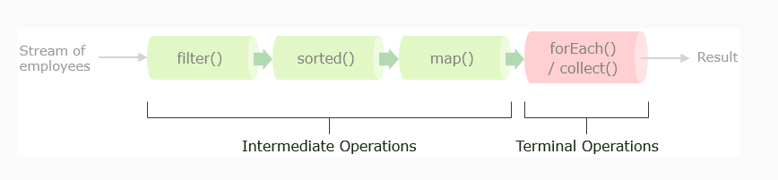

5.2 Parallel Streams:
We have seen how streams can be used to perform operations such as filtering, sorting, etc. in a declarative way, making the syntax concise and easy to use.
However, with such operations at extensive levels comes the issue of performance and resource utilization. For example, operating on millions of records sequentially can degrade performance. Multithreading can provide a noticeable advantage here, but it has always been a challenging task for developers.
With the introduction of advanced concurrent programming features in Java, streams in the form of parallel streams not only utilize multithreading, but also provide a significant abstraction over thread pool management and the fork-join framework. This helps in utilizing the power of multicore CPUs for parallel processing in a simple declarative way.
Here's a familiar example using the parallelStream() method to retrieve a parallel stream from a collection:
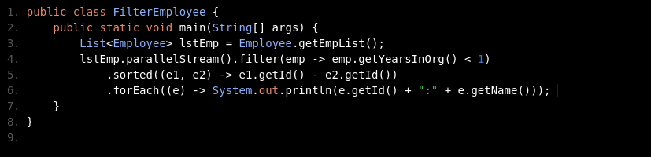
Parallel stream divides its elements into several chunks and processes each chunk on a different thread. By default, parallelStream() creates threads whose count equals the number of processors available.

Though parallel stream may look like an answer for faster performance, it may not always be the case. So benchmarking the performance and verifying the performance gain is an advisable step. Also checking the operations which are being used in the stream can help in deciding when to use parallel streams. Operations which are dependent on the ordering of the elements like limit(), findFirst(), etc. are quite expensive in parallel stream.

6. Optional Class:
When we look at the reasons for application failures, NullPointerException finds its place at the top.
Using the if construct has become the most common way of performing null checks. We know this is the construct most widely used for writing business validations. However, null checks do not directly contribute to business functionality.
In approaches like ours, there is no clear demarcation between null checks and business logic. And it would be convenient if null checks could be decoupled from the business logic.
For this, Java 8 gives us the Optional class.
The Optional Class, present in java.util.package, represents a container which may hold null or non null values. It provides the number of methods to perform null check without polluting the code.
private Optional<Passport> passport = Optional.empty();

7. Need for Date / Time API:
The offset of 1900 has been a source of bugs, and the time component has often interfered with the programming.
Moreover, the Date class is mutable (as observed in Exercise 12), hence not thread safe and will produce ambiguous results when used in a multi-threaded environment.
To fix these issues java.util.Calendar was introduced in Java 1.1
Unfortunately, Calendar couldn't overcome all the shortcomings of the Date class:
- It also contains both the date and time components
- Although the year offset problem has been resolved in Calendar, January is still represented by 0 instead of 1
- Calendar cannot be directly formatted
- It is mutable and not thread safe just like the Date class
To address these issues, third-party libraries like Joda Time were being used.
But, now with the Date/Time API, these problems can be well addressed.

7.1 Local Date :
java.time.LocalDate is an immutable, thread-safe class whose instances represent date without the time and time-zone components. Some of its methods are listed below:

Method | Description
LocalDate.now() | Gets the current system specific date
LocalDate.of(int year, int month, int day) | Returns LocalDate of given year, month and day
LocalDate.plusDays(long days) LocalDate.plusMonths(long months)  LocalDate.plusYears(long years) | Gets copy of the LocalDate after adding number of days/months/years that is passed
LocalDate.parse(CharSequence date) | Returns LocalDate from the character sequence (2018-11-11) passed
LocalDate.  compareTo(ChronoLocalDate date) | Compares the LocalDate instance on which this method is invoked with the LocalDate instance supplied as argument

7.2 Local Time :
Similar to LocalDate, java.time.LocalTime as well is an immutable class that is thread-safe. Its instances represent time without date and time-zone. Some of its methods are listed below:

Method | Description
LocalTime now() | Returns current system specific time
LocalTime of(int hours, int minutes, int seconds) | Returns LocalTime from the hours, minutes and seconds passed
LocalTime plusHours(long hours)  LocalTime plusMinutes(long minutes),  LocalTime plusSeconds(long seconds) | Gets copy of LocalTime after adding the number of hours/minutes/seconds
LocalTime parse(CharSequence time) | Returns LocalTime out of the character sequence (e.g. 05:09) passed
int compareTo() | Compares the LocalTime instance on which this method is invoked with the LocalTime instance supplied as argument

8. Java Basics:

8.1 Access Control :
1. Classes and Interfaces cannot apply private modifier. But Inner classes can be private.
2. Any methods declared public in superclass should be public in overriden subclassess
3. Any methods declared protected in superclass should be public or protected in sub classes.
4. Interfaces cannot have private methods or fields.
5. Default modifier can be accessed within same package.

8.2 Non Access Control :
1. Static variable values can be changed only if calling method is static.
2. Instance variables cannot be called from Static methods, since static is Class level.
3. Initially if the Final is declared and not initialized, then it can be initialized only by constructors. And constructors cannot be defined as final as they cannot be inherited.
4. static final which is not initialized can be initialized in static block.
5. Abstract and final cannot be used together.
6. Transient cannot be used with static keyword.
7. Volatile canbe used with static keyword.
8. Static can be used in inner classes. For Ex: static class innerclass {}

8.3 Collections :
1. Interfaces:
- Collections extends Iterator
- List extends Collection
- Set extends Collection
- SortedSet extends Set
- NavigableSet extends SortedSet
- Queue extends Collection
- Dequeue extends Queue
- BlockingQueue extends Queue
- Map<K,V>
- SortedMap extends Map
- NavigableMap extends SortedMap
2. Classes:
ArrayList implements List,RandomAccess (Marker Interface):
Insertion and deletions is slow
Random Access is easy. (Iteration is fast)
Vector implements List, RandomAccess: - methods are synchronized. (Thread safe)
Same as Arraylist except thread safe.
Linked List Implements List, Queue:
Inserstion and deletion is fast
Iteration is slower than ArrayList.
HashSet Implements Set: //Similar to HashMap
Unordered, Unsorted – iterates in in random order.
LinkedHashset Implements Set: //Similar to LinkedHashMap
Ordered, Unsorted – iterates in order of insertion
TreeSet implements Set, NavigableSet: //Similar to TreeMap
Ordered, Sorted

TOPIC 6: Angular JS 6 NOTES

1. What and Why?:
- Framework to build client side applications.
- Greate for Single page applications
- Modular approach
- Because of componants there are lots of Re-Usable codes.
- Unit Testable.
- It is from Google team and make use of Microsoft’s product Typescript.

2. Angular’s History:
2010 – Angular JS (Controller Approach)
2016 – Angular version 2 + (onwards Componant Approach)

3. Angular’s Architecture:

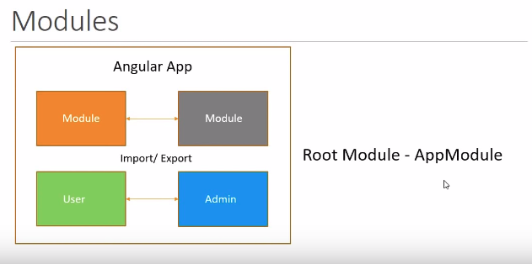

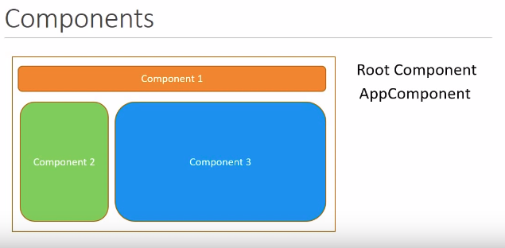
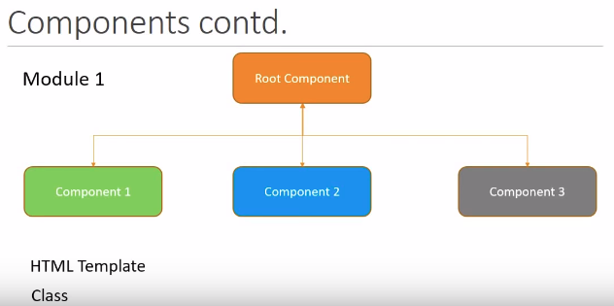

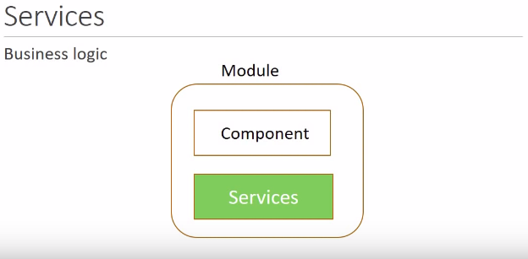

- Angular app – one or more modules
- Module – one or more componants and services
- Componants – HTML + Class
- Services – Business Logic
- Modules interact and ultimatly render the view in the browser.

4. Important files in Angular app:
- Package.json - It contains all dependencies of angular app.
- Node.modules - All the packages get copies here.
- Src/main.ts - This is the entry point to angular app
- Src/app/app.module.ts – Root module of angular app
- Src/app/app.componant.ts – Root componant of angular app Class
- Src/app/app.componant.html – Contains html template HTML

5. Componants:
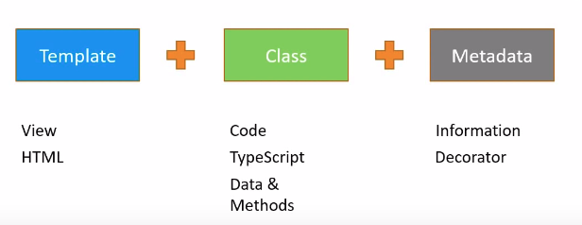
App.components.ts:
@Component({
selector: 'app-root', - 1
templateUrl: './app.component.html', - 2
styleUrls: ['./app.component.css'] - 3
})
1:
- selector: 'app-root' - <app-root>
- selector:'.app-root' - <div class=’app-root’></div>
- selector:'[app-root]' - <div app-root></div>
2:
- templateUrl:'./app.component.html'
- template:’<div>Inline template</div>’
- template:`<div>
Inline template - Multiline template
</div>`

6. Interpolation:
With the interpolation we can bind data from the class to html template.

6.1 Things can be done in Interpolation:
@Component({
selector: 'app-test',
template: `
<h2>
Welcome {{name}} - Interpolation Render
</h2>
<h2>{{2+2}}</h2>
<h2>{{“Welcome” + name}}</h2>
<h2>{{name.length}}</h2>
<h2>{{greetUser()}}</h2>
`,
styles: []
})

export class TestComponent implements OnInit {
public name = "Ushan"; - Interpolation from Class
constructor() { }
ngOnInit() {}

greetUser(){
return “Hello “ + this.name;
}
}

6.2 Things can not be done in Interpolation:
@Component({
selector: 'app-test',
template: `
<h2>{{a=2+2}}</h2> - Uncaught Error: Template parse errors:
Parser Error: Bindings cannot contain assignments at column
<h2>{{window.location.href}}</h2> - Cannot Read property Location
<h2>{{name.length}}</h2>
<h2>{{greetUser()}}</h2>
`,
styles: []
})

7. Property Binding:

7.1 Attributes vs Properties:
- Attributes and properties are not same.
- Attributes are defined by HTML where Properties are defined by DOM.
- Attributes initialize DOM properties and then they are done. Attribute values cannot change once they are initialized. Property values however can change.
<input [id]="myId" type="text" value="Codevolution"/> - Property binding Will work
<input [disabled]="{{false}}" type="text" value="Codevolution"/> - Interpolation Will not work
Inside class : public myId = “testId”;
Instead of [disabled] we can use bind-disabled too with in tags.

8. Class Binding:
@Component({
selector: 'app-test',
template: `
<h2 [class]="textDanger">Ushanandhan M</h2>
<h2 [class.text-success]="hasSuccess"> Status </h2>
<h2 [ngClass]=”messageClasses”>Message Classes </h2>
`,
styles: [`

.text-danger{
color:red;
}
`]
})

export class TestComponent implements OnInit {
public textDanger="text-danger"; - Class Binding...
public hasSuccess=true;
public isSpecial = false;
public messageClasses={
“text-success”:!this.hasError,
“text-danger”:this.hasError,
“text-special”:this.special
}

9. Style Binding:
@Component({
selector: 'app-test',
template: `
<h2 [style.class]=”hasError?red:green”>Message Classes </h2>
`,
styles: [``]
})

10. Event Binding:
@Component({
selector: 'app-test',
template: `
<button (click)=fireEvent(event)>Send Event</button>

`,
styles: [``]
})

fireEvent(event){
console(event); - This event parameter will give us entire details from
} where it is triggered.

11. Reference variable:
@Component({
selector: 'app-test',
template: `
<input #myText type=’text’> - Reference variable.
<button (click)=fireEvent(myText.value)>Send Event</button>

`,
styles: [``]
})

fireEvent(value){
console(value);
}

12. Two way Binding:
@Component({
selector: 'app-test',
template: `
<input [(ngModel)]=’name’ type=’text’> -
{{name}}

`,
styles: [``]
})

lets have name property in the class.

TOPIC 7: Docker

1. Docker Commands:

7.1 Basic Docker Commands:
1. Docker run :
docker run image-name
example : docker run mysql
2. To execute command in running container:
docker exec -it image-name bash
example: docker exec -it mysql-standalone bash
3. List the running containers:
docker ps
4. List all the containers:
docker ps -a
5. Detach from container once it is started:
docker run -d image-name
6. Attach to container:
docker attach container-id

7. Stop container:
docker stop container-id
8. Remove container:
docker rm container-id
9. List all Images:
docker images
10. Remove images:
docker rmi image-id

11. Remove multiple container / images:
docker rm <first three letters of continer id with seperting with space>
Example : docker rm 345 867 932
docker rmi <first three letters of image id with seperting with space>
Example : docker rmi 345 867 932
12. Pull image and not run:
docker pull image-name
13. Run image with specified tag (version):
docker pull image-name:<<version>>
14. To give input to the container:
docker run -i image-name
15. Port Mapping:
docker run -p 6060:8080 image-name:tag-name (version name)
Outside Docker port
Docker port
16. Volume Mapping outside docker: (For Example Persist Mysql data outside docker)
docker run -v /opt/datadir:/var/lib/mysql mysql
17. To find the logs:
docker logs image-name
18. To inspect container: (Full details about container)
docker inspect container-name or container-id
Here we can find the docker ip address from the json file

19. To Name the container:
docker run –name <<container-name>>

2. Docker Images:
1. Create Dockerfile:
FROM openjdk:8
ADD target/project.jar project.jar
EXPOSE 6060
ENTRYPOINT ["java","-jar","project.jar"]
2. Build the image:
docker build -f Dockerfile -t <<any image name>> .

This indicates root folder
3. Push to Docker hub: (Before this please login to ur docker hub account)
docker login
docker push <<account-name>>/<<image-name>>
4. To set environment variables specify -e as below:
docker run -e APP_COLOR=blue -p 7070:6060 -d image-name:tag-name
5. Docker Entry points vs Commands:
CMD will not append the command line input while running the container.
Entrypoint will accept the command line input while running the container.
Example:
ENTRYPOINT [“sleep”]
CMD[“5”]
Here sleep will execute with default value 5 specified with CMD.
docker run ubuntu sleep

3. Docker Compose:
1. Docker Links:
docker run -p 8080:8080 –name container-name –link mysql-container-name:mysql -d image-name.
Like this we can link our db containers to web application images.

2. Docker compose-yaml:
Assuming already required images are built then below yml file will up the container with below command
docker-compose up
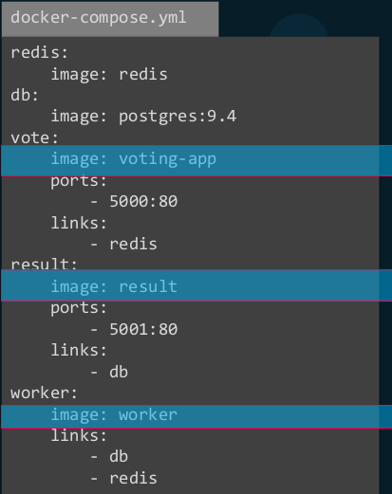

If Images are not build then we can use below yml file where we can specify build command to the folder in which we have Dockerfile.
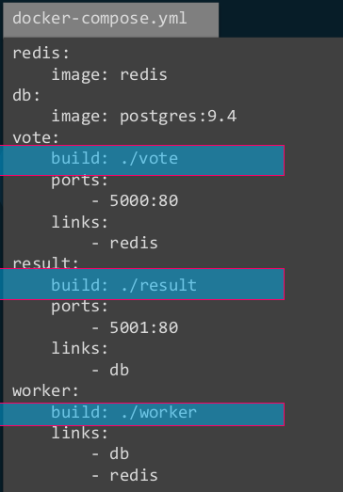

3. Multiple version of docker compose yml is present. Please specify the version on topof it. That will help docker understand which version is running.
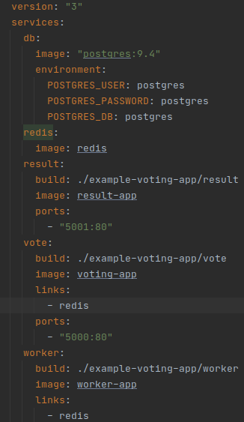

4. Docker Registery:
It is repository from where we pull all required images. We can have private repository where we can push our images.
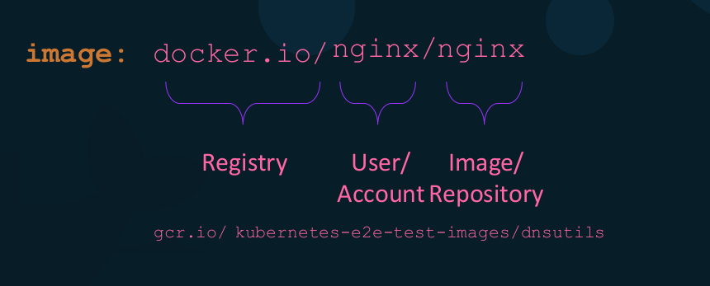

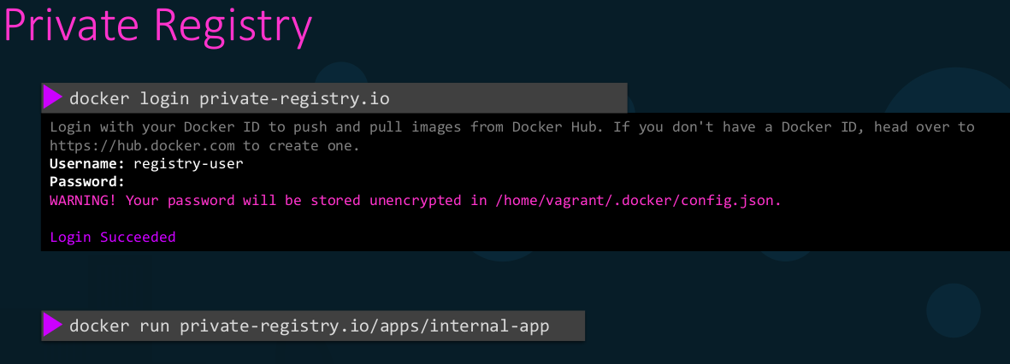
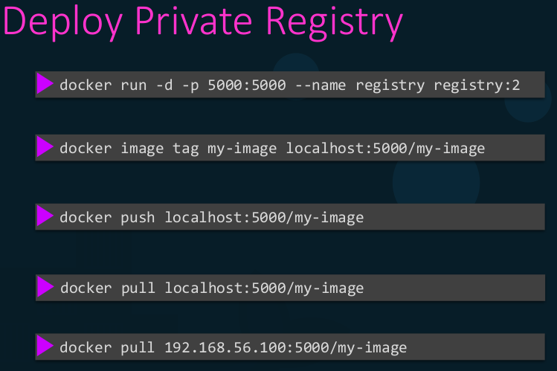

5. Docker Engine:
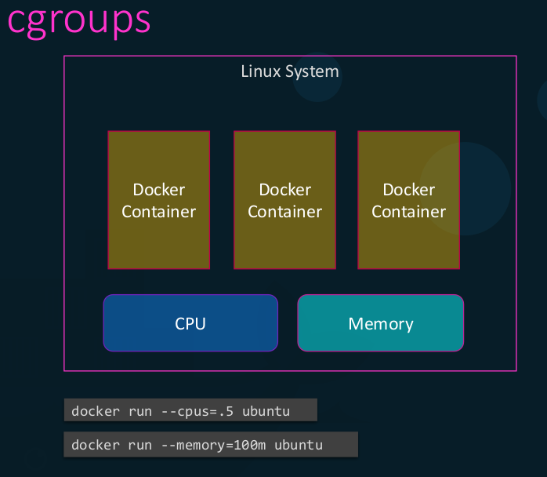

We can specify cpu utilization and memory using above command displayed in the picture.

6. Docker Storage:
Docker stores every thing under /var/lib/docker/
To find this type docker info
We can mount volume outside docker by giving -v outside-docker-path:inside-docker-path

7. Docker Networking:
NETWORK ID NAME DRIVER SCOPE
6386e1e6f974 bridge bridge local
8b89e3388c32 host host local
b3dc159371bf none null local
docker run --name alpine-2 --network=none alpine

`

TOPIC 8: Spring Security

1. Dependecy:
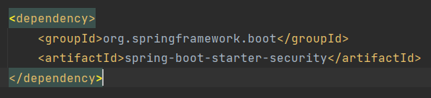

2. How it works:
The request will first intercept by DelegatingFilterProxy and then on validating the credentials it will redirect to intended request. In Spring Security request will go to first AuthenticationManagerBuilder and then with the help of AuthenticationManager implemented in ProviderManager will find the AuthenticationProvider and trigger the method Authenticate(). Authentication will receive credentials as input. On validation it will provide output as principle. Each AuthenticationProviders have support() method which will say whether the intended request supports this type of authentication. Once AuthenticationProvider’s authenticate() method is triggered it will check for any class implemented by the interface UserDetailsService of Spring security. This class has method called loadUserByUserName().
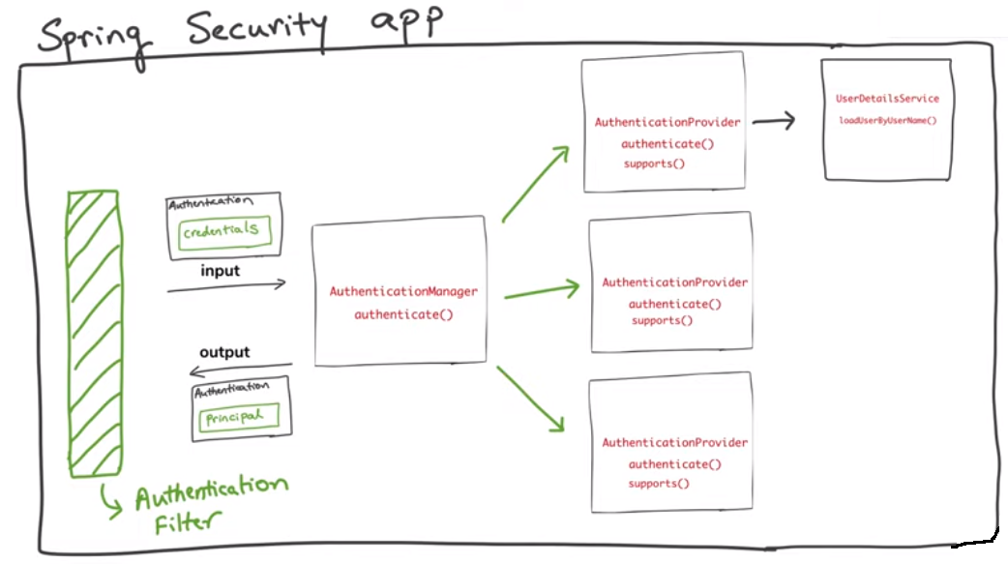
Once the Authentication is passed, Authentication object is saved in the ThreadLocal. SecurityContext will have the access to ThreadLocal which will have Authentication object.

3. Steps Involved JDBC Authentication:

3.1 SecurityConfig:
1. Create one configuration class SecurityConfig.
2. Extend it with WebSecurityConfigurerAdapter to inform spring to use our configuration class to load security related details.
3. Annotate this class as @EnableWebSecurity. This will give AuthenticationManagerBuilder object.
4. Override configurer(AuthendicationManagerBuilder Auth) method to inform which type of authentication we are going to use.
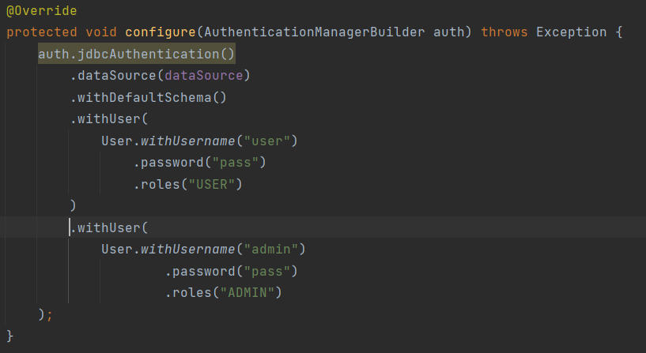
5. For Authorization we need to override another configurer method which take HttpSecurity as a parameter.
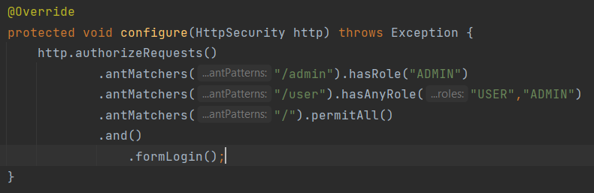
6. Finally add PasswordEncoder bean here to encode the password. For now we can use NoOpPassWordEncoder for test purpose. But this is not recommended.
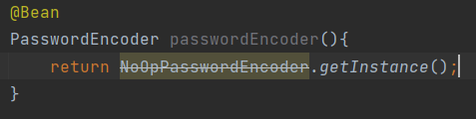

7. Spring User Details schema can be created with the help of following link.
https://docs.spring.io/spring-security/site/docs/current/reference/html5/#user-schema
8. Remove default user details from configurer method and keep user details in datasource.
9. Have controller where we can have three urls such as (“/”,”/user”,”admin”).

4. Steps Involved JPA Authentication:

4.1 SecurityConfig:
1. Just like previous Authentication we do not have predefined JPA support authentication. Instead we have method called userDetailService() method which will take its implementation as parameter.

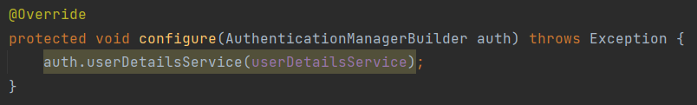
4.2 User Details Service:
1. Create a MyUserDetailsService class and implement it with UserDetailsService. This will give loadUserByUserName(String username) method where we can implement our logic. Here we created User model and repository. Then with the repository we get the user credentials and set them in UserDetails implemented class MyUserDetails.
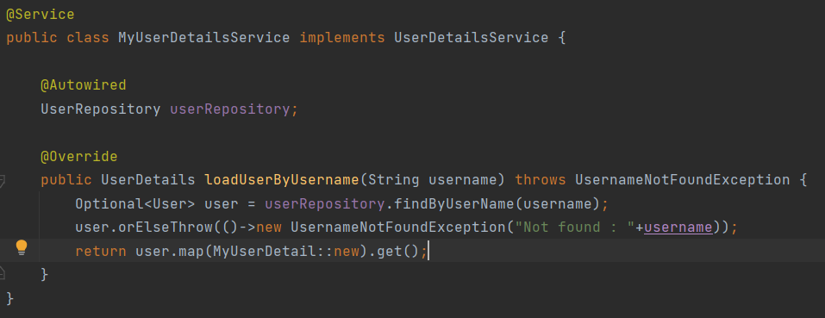

4.3 User Details Model:
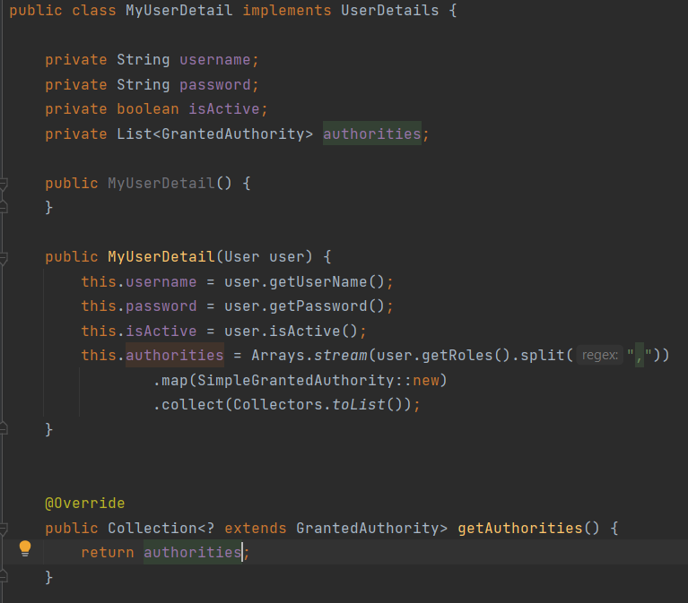

4.4 User & Role Model:
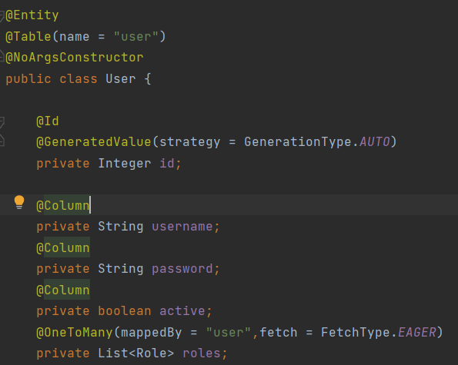

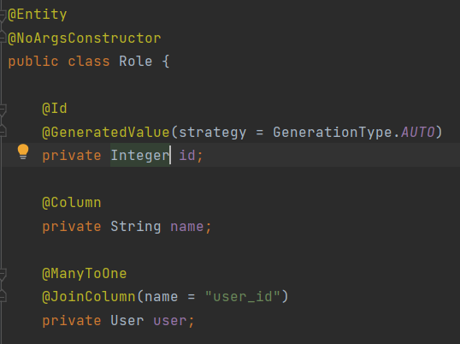

5. Steps to enable HTTPS in spring boot:

5.1 Create certificate using java:
Go to cmd with Admin privilate and navigate to Java’s bin location. Enter below command,
.\keytool -genkey -alias bootsecurity -storetype PKCS12 -keyalg RSA -keysize 2048 -keystore bootsecurity.p12 -validity 3650
Highlighted one is user defined name.
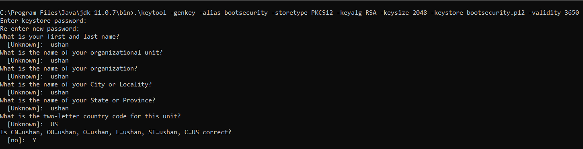
Once done, generated certificate will be available in bin folder. Cut and paste it in the resources
folder of Spring boot application.

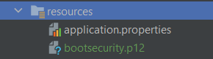

5.2 Update application.properties file:
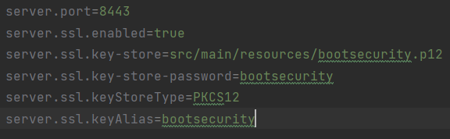

5.3 Add bean into our application:
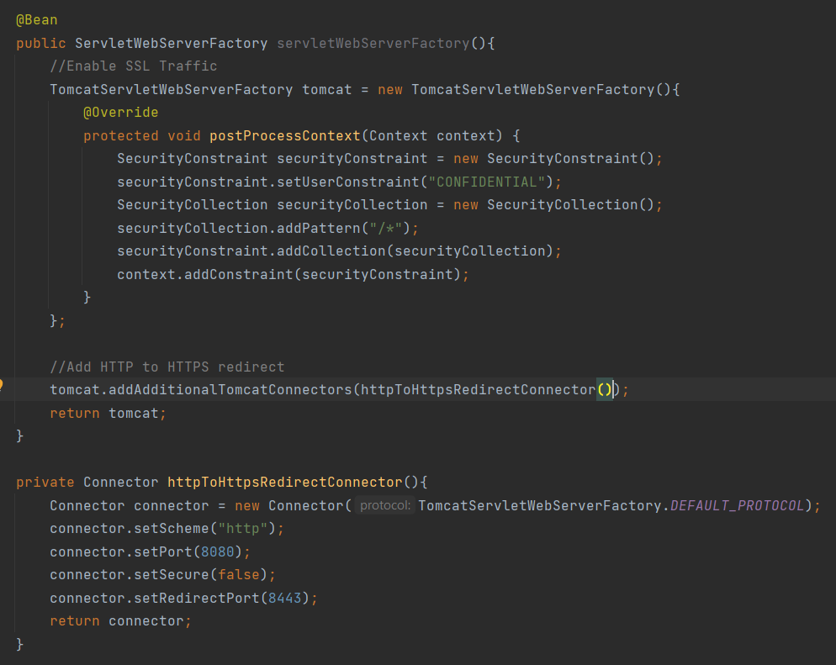
Now our application is secured with HTTPS.

TOPIC 9: Gitlabee

1. .gitlab-ci.yml:
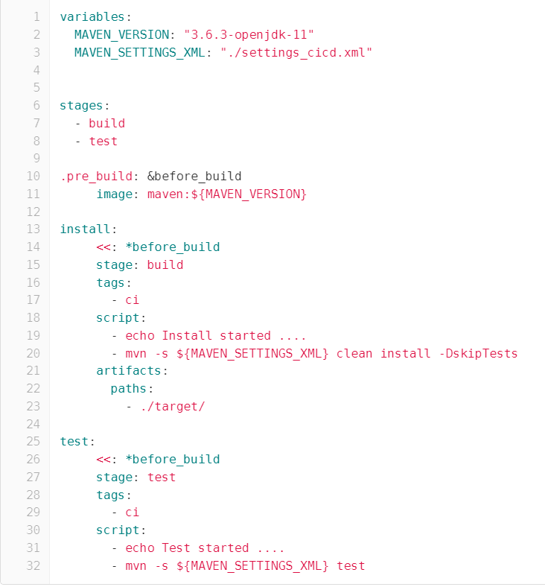

1.1 Manage Secrets:
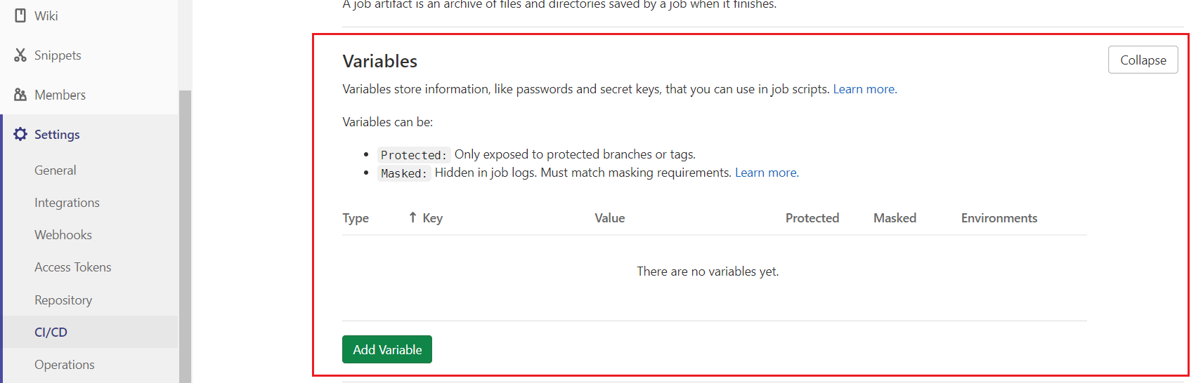

1.2 Yaml Basics:
1. To disable the job add (.) dot in front of the job.
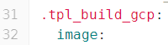

2. Anchors: (aliases)
This is used to replicate the value present in one place to another. & is used to specify the alias name. We can give any name. To use this alias we should use the name along with * in front of it.
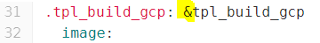
Alias & Used

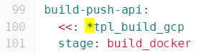
* is used to specify the alias which we need to use.
<< is used to merge that alias properties in this job.

TOPIC 10: Kubernates

1. Concepts:

1.1 POD:
A pod is the smallest execution unit in Kubernetes. A pod encapsulates one or more applications. Pods are ephemeral by nature, if a pod (or the node it executes on) fails, Kubernetes can automatically create a new replica of that pod to continue operations.
Commands:
1. kubectl get pods:
To get list of pods in the node.
2. kubectl get pods -o wide:
To get list of pods with details.
3. kubectl describe pod pod-name:
To describe the pod details.

1.1.1 Creating POD using YML:
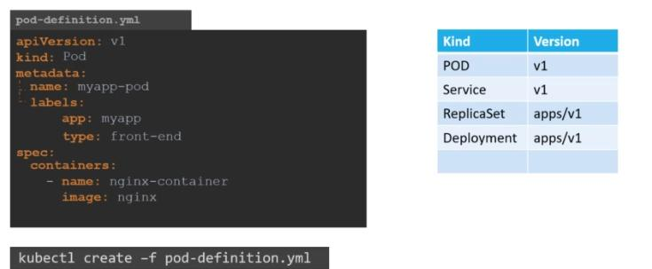
Kubectl apply -f pod.yml – To create pod and run it.
Vim pod.yml – To edit the file in vim editor in linux.
Cat pod.yml – To view the changes edited in linux.

1.2 ReplicaSet:
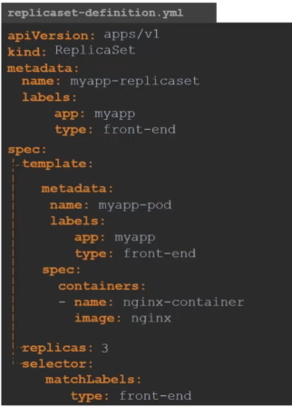
Commands:
1. kubectl create -f replicaset.yml : To Create replicaset.
2. kubectl get replicaset : To get replicasets.
3. kubectl get pods: To get Pods.
To upgrade the replicaset:
First-way:
1. edit replicaset.yml where set replicas: <<desired count>>
2. run command - kubectl replace -f replicaset.yml.
Second-way:
1. Without editing the file simply run below command.
Kubectl scale –replicas=<<desired count>> replicaset.yml.

1.3 Deployments:
In yaml file just like before give kind as deployment. Then name it as deployment.yml.
Commands:
- kubectl create -f deployment.yml – To create deployment.
- kubectl get deployments – To get all deployments.
- Kubectl get replicaset – To get all replicasets.
- Kubectl get pods – To get all pods.
- Kubectl get all – To get all details in one place.
- Kubectl apply -f deployment.yml – To replace and update deployment.

1.3.1 Deployments Updates & Rollbacks:
Commands:
Rollout: kubectl rollout status deployment/<<deployment-name>>
History: kubectl rollout history deployment/<<deployment-name>>
Deployment Strategy:
Recreate: It will destroy every pod and add latest version into kubernate.
Rolling Update: It will gradually destroy and update pod one by one.

1.4 Networking:

